Objective

In app.bw.com, we see there are two types of APIs which are present. First one is the login API. The second one is called the registration API or signup API.
In the login API, the user will enter the email and password, which is a working password that they have. If it is valid, we will be able to log into the dashboard. If it is invalid, then we will get an error.

Login

- URL
- Payload
- HTTP Method
- Status
- What to verify

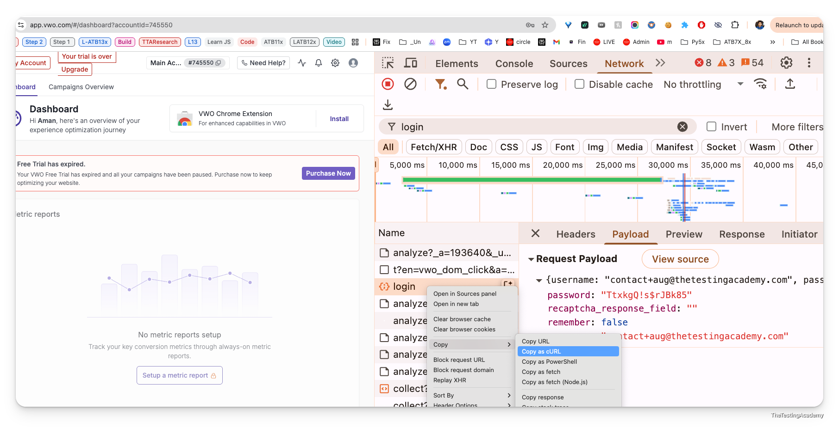
curl 'https://app.vwo.com/login' \
-H 'sec-ch-ua-platform: "macOS"' \
-H 'Referer: https://app.vwo.com/' \
-H 'User-Agent: Mozilla/5.0 (Macintosh; Intel Mac OS X 10_15_7) AppleWebKit/537.36 (KHTML, like Gecko) Chrome/137.0.0.0 Safari/537.36' \
-H 'sec-ch-ua: "Google Chrome";v="137", "Chromium";v="137", "Not/A)Brand";v="24"' \
-H 'DNT: 1' \
-H 'Content-Type: application/json;charset=UTF-8' \
-H 'sec-ch-ua-mobile: ?0' \
--data-raw $'{"username":"contact+aug@thetestingacademy.com","password":"TtxkgQ\u0021s$rJBk85","remember":false,"recaptcha_response_field":""}'

Registration

- URL
- Payload
- HTTP Method
- Status
- What to verify
- Request body
- Response body
- Header
- Auth
- Cookie
- Token?

